**Chicago Crime Data Analysis**

**Screen Shots**

**Alteryx Job : Initial Load From TSV  
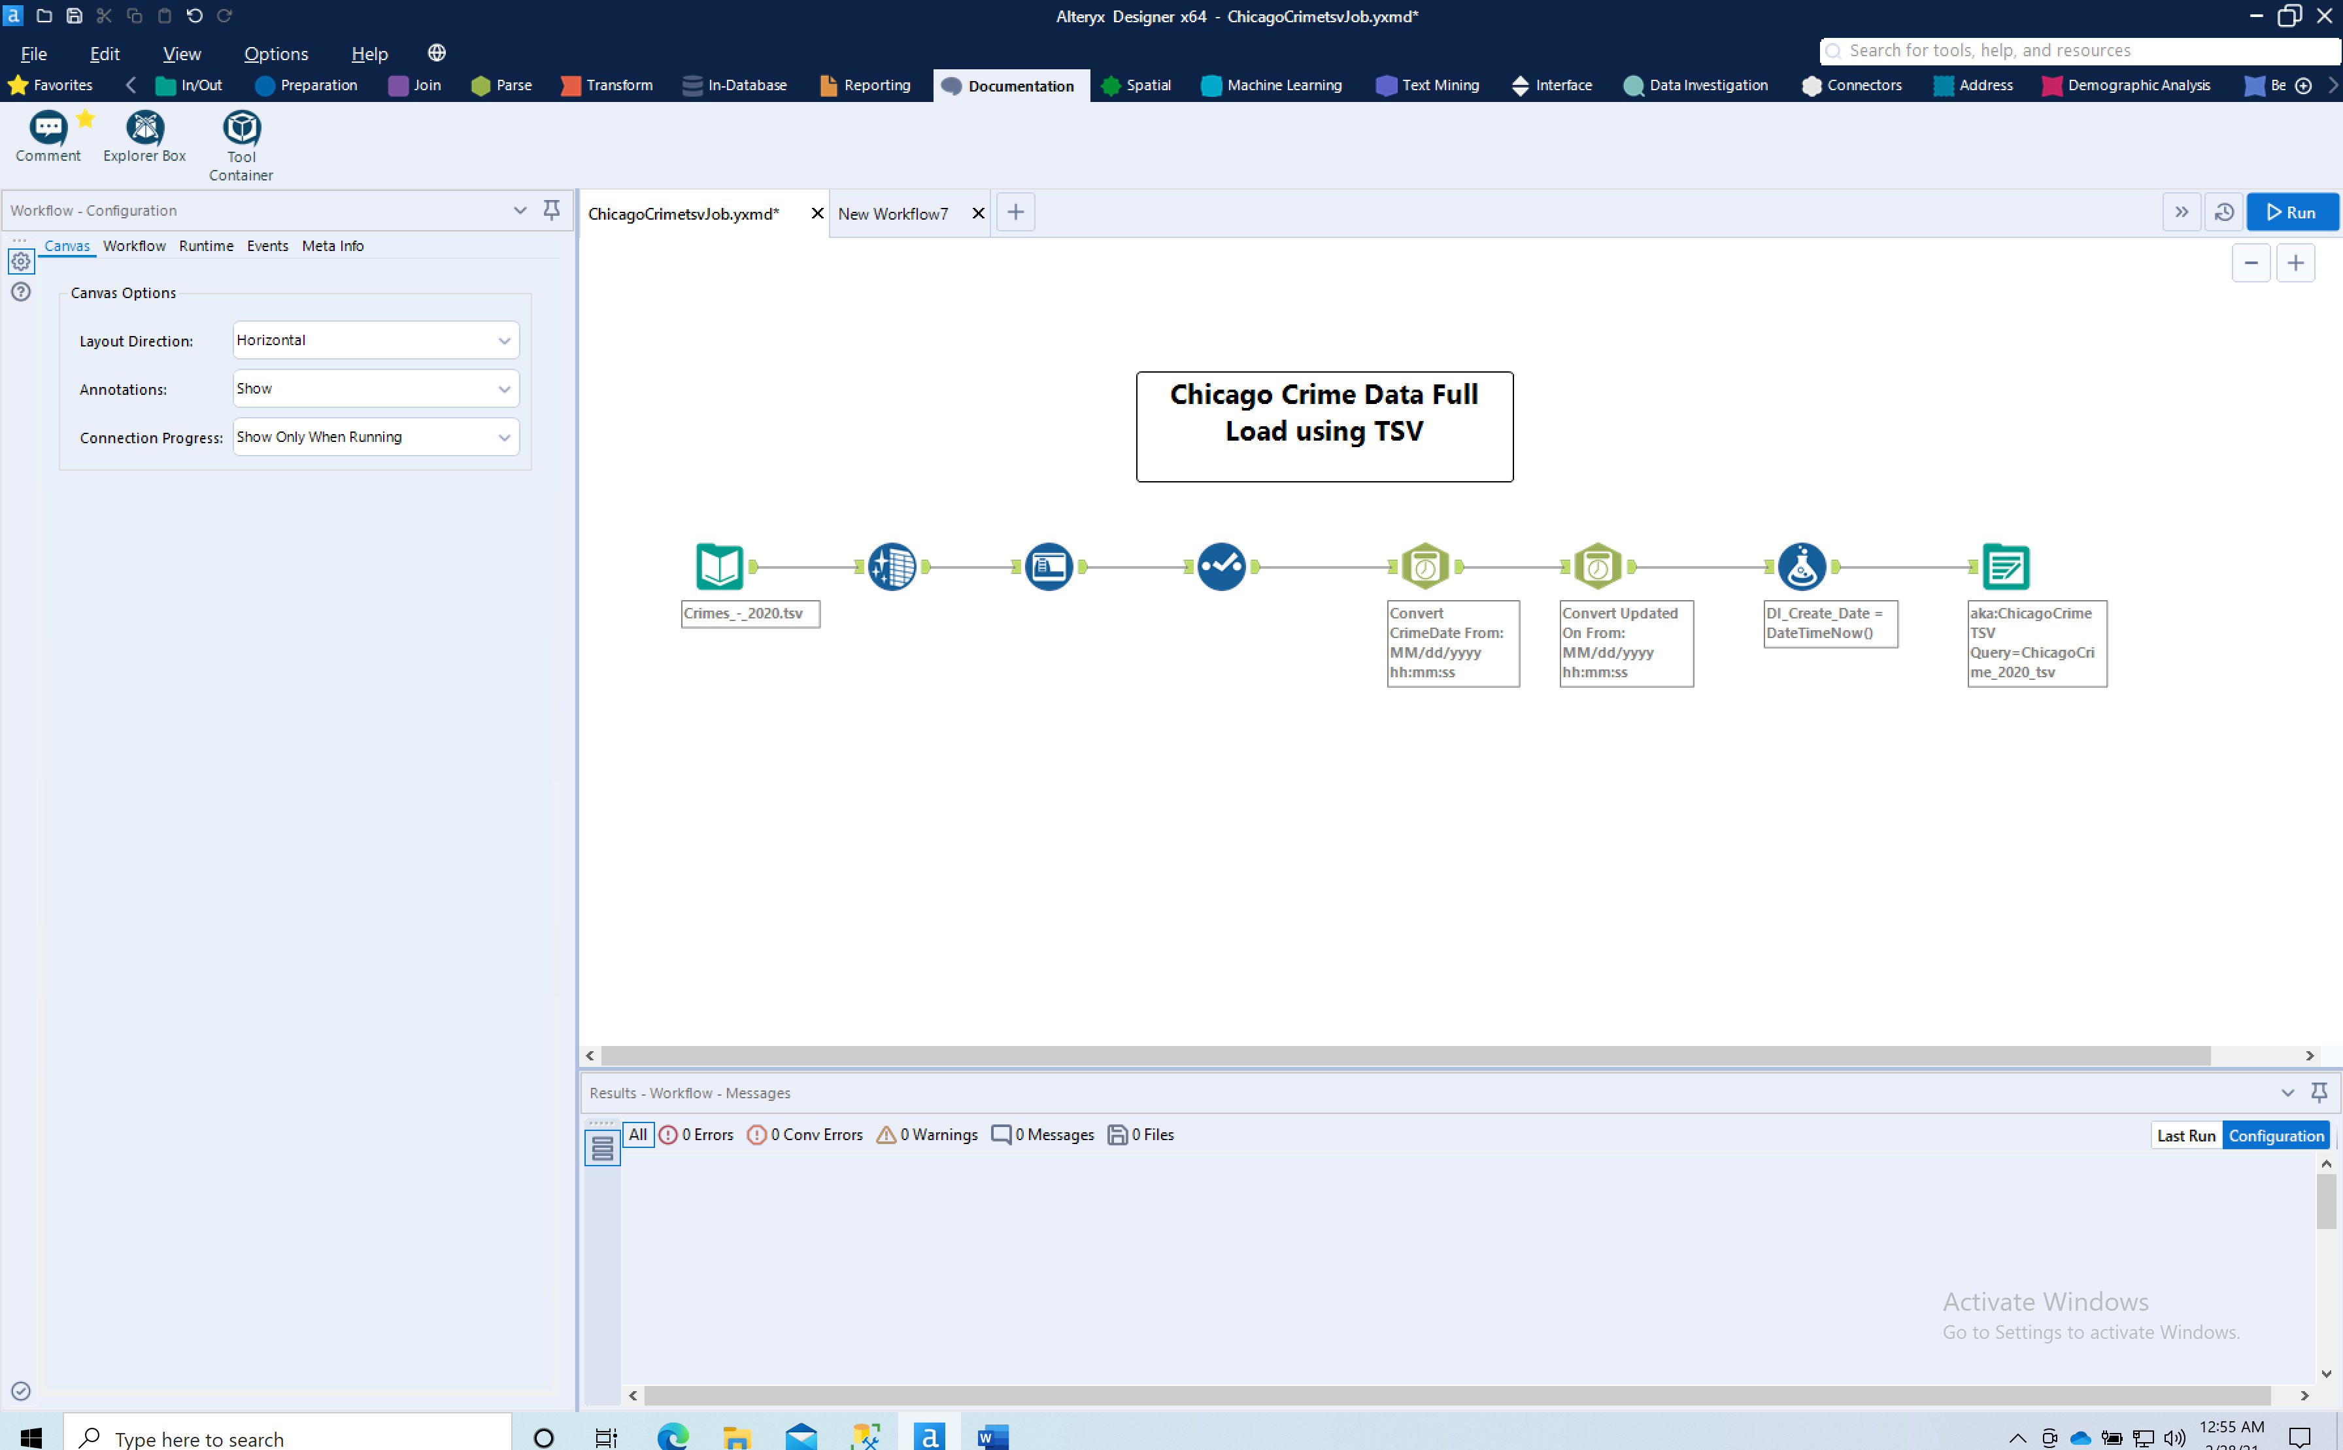**

**Database: info7370, Table : ChicagoCrime_2020_tsv**

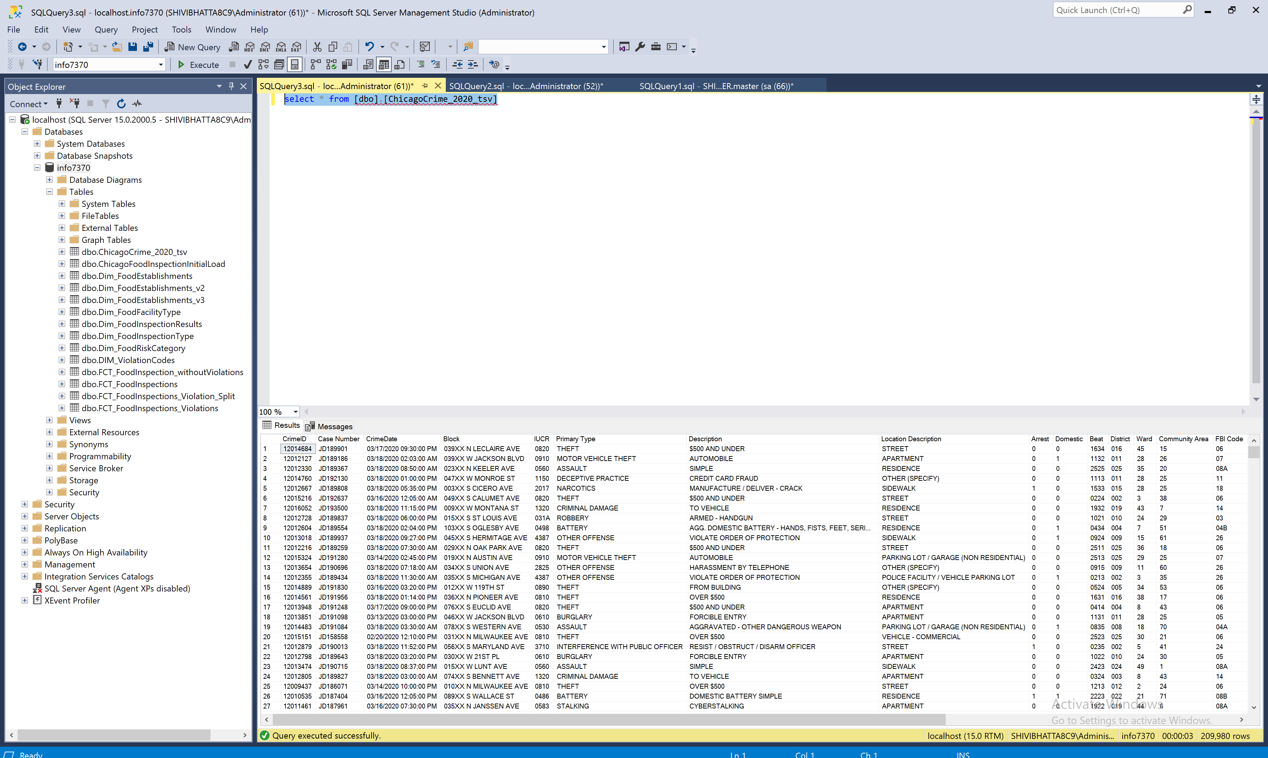

**Alteryx Job : Google Big Query Full Load:   
  
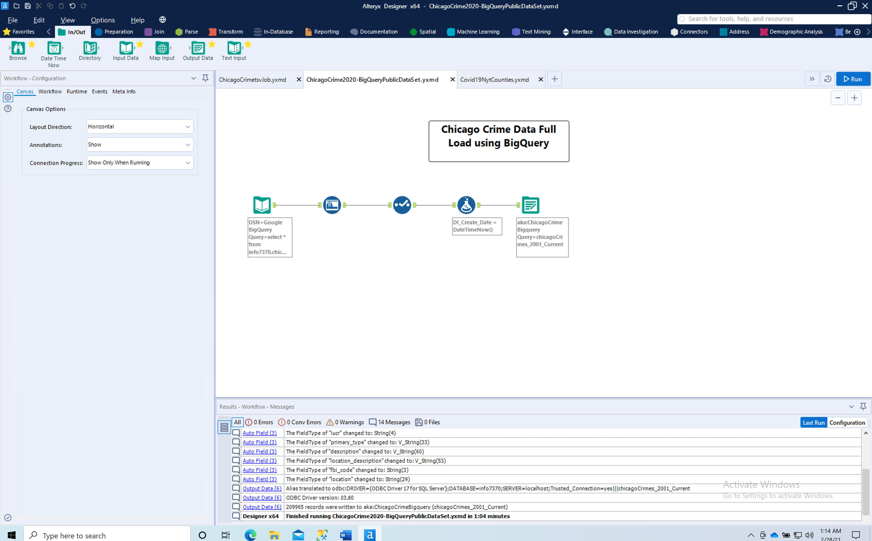**

**Database : info7370 , Table : chicagoCrime_2020_current:  
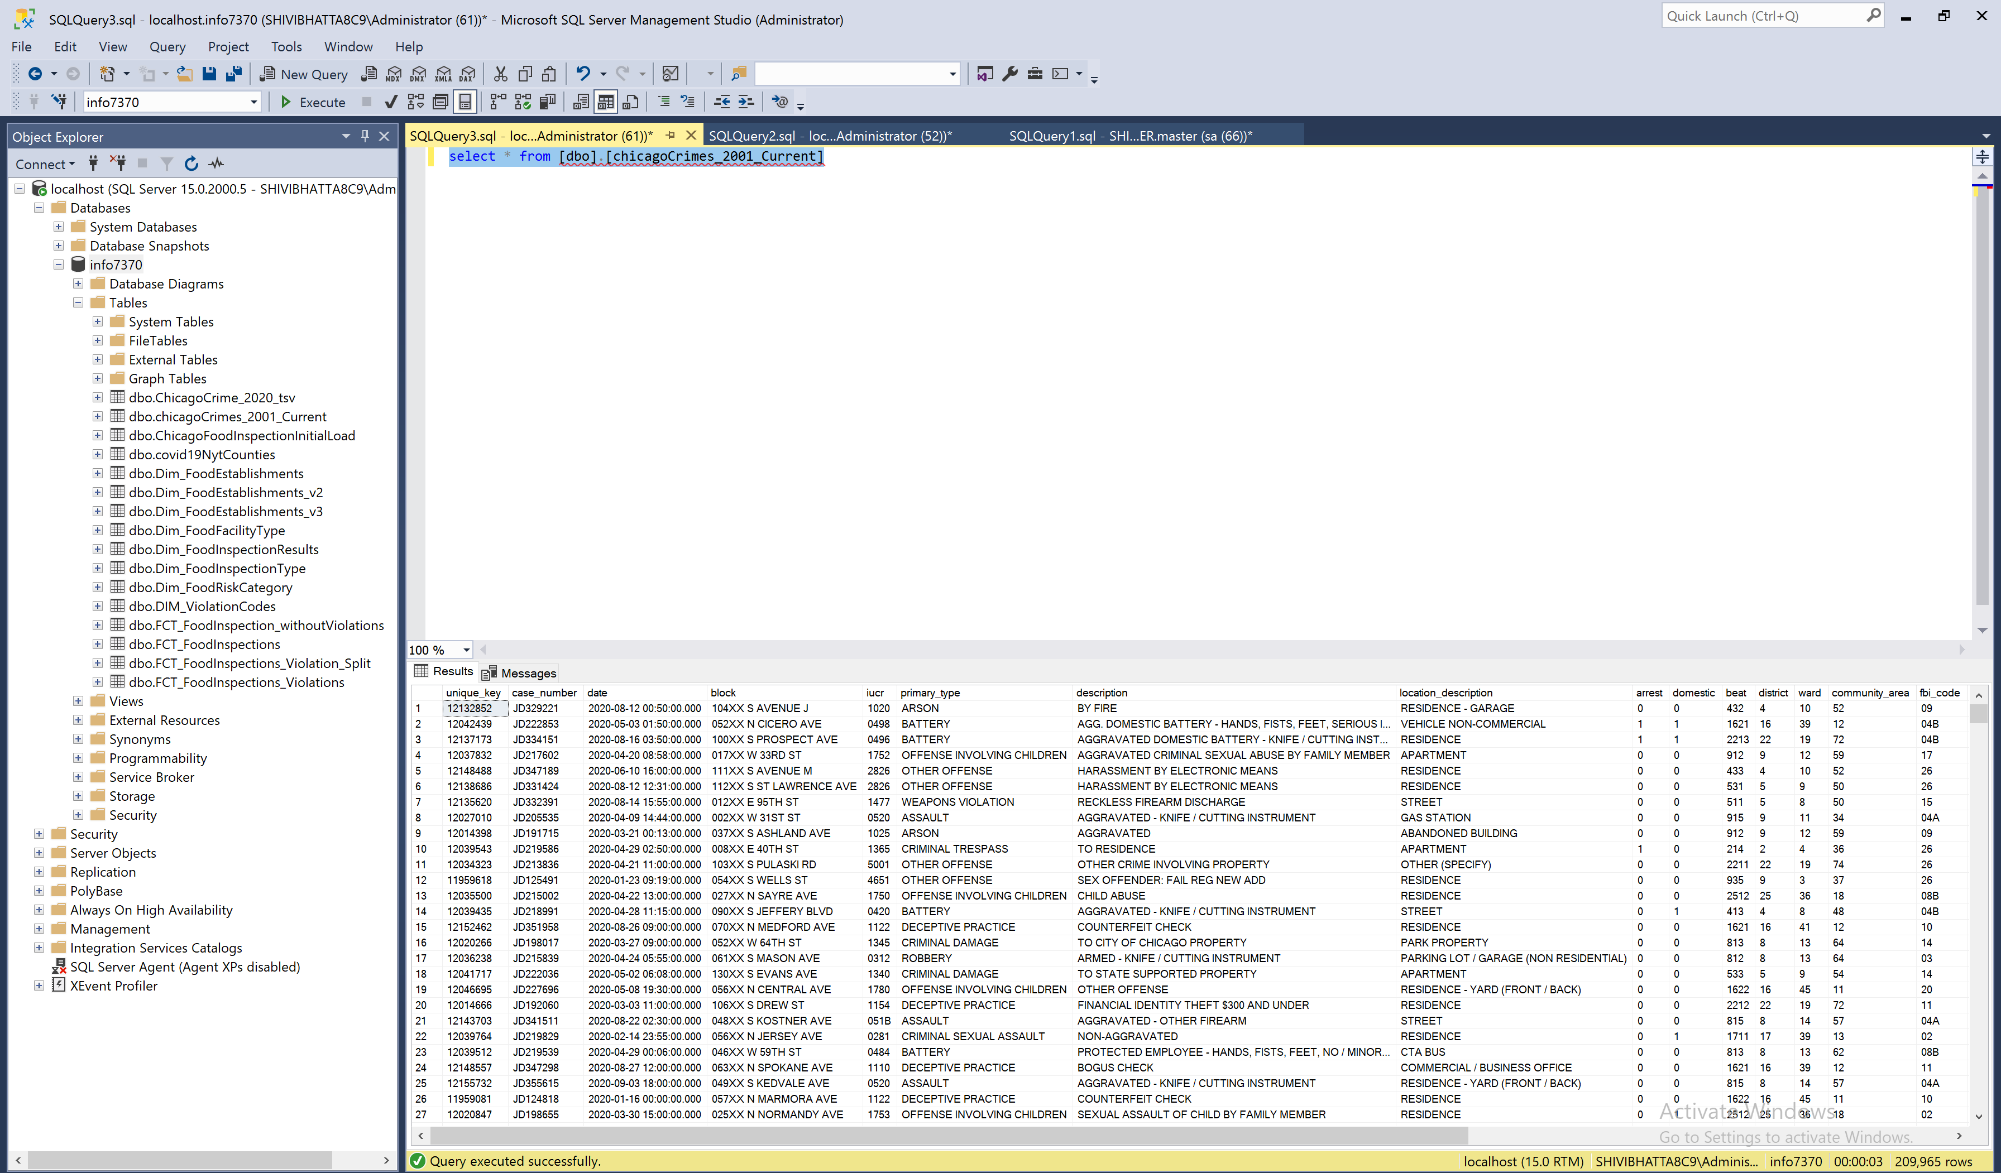**

**Alteryx job : Covid19NytUS Counties :   
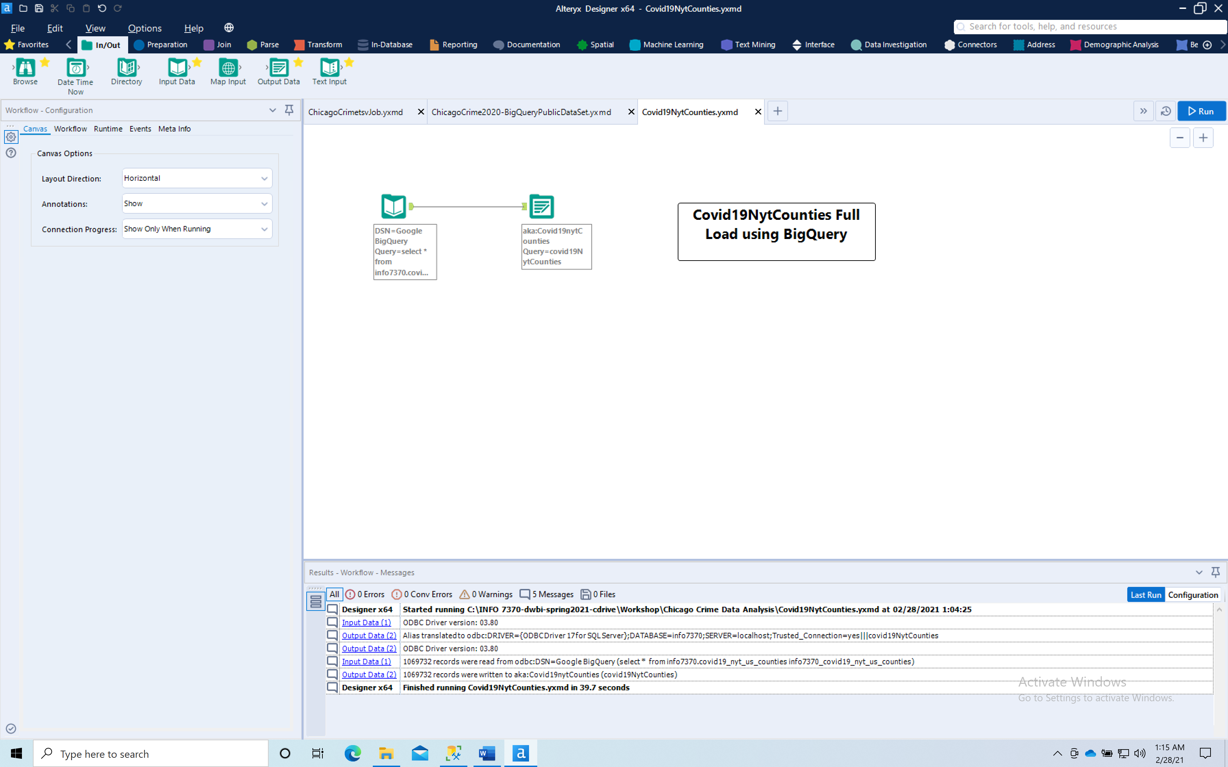**

**Table : Covid19nytUSCounties:  
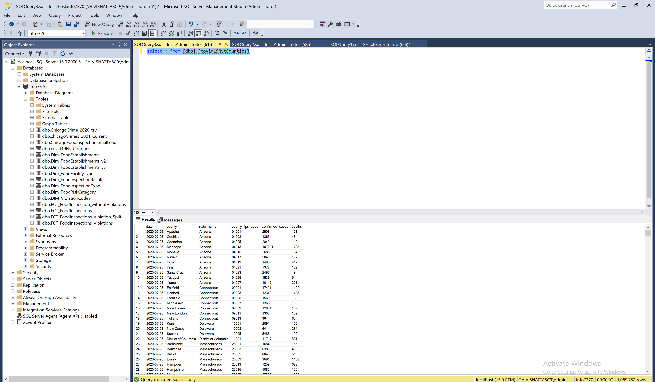**

**Chicago Crime Dimensions:  
  
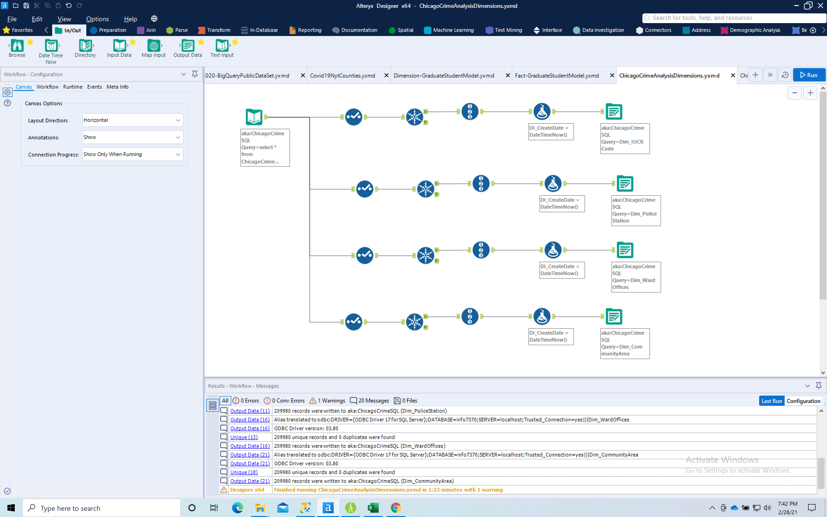**

**Table : Dimensions : IUCR**

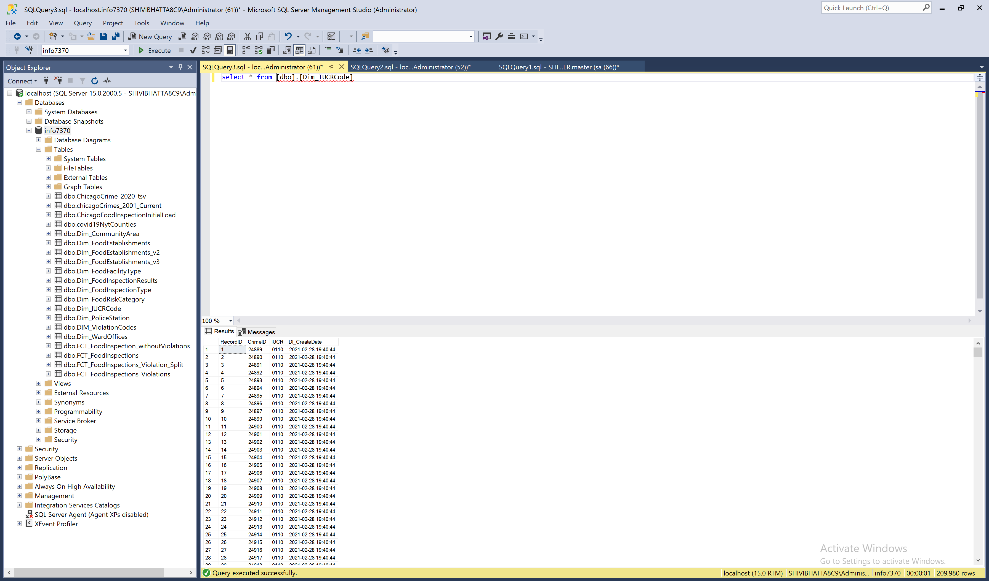

**Dimension : Police Station**

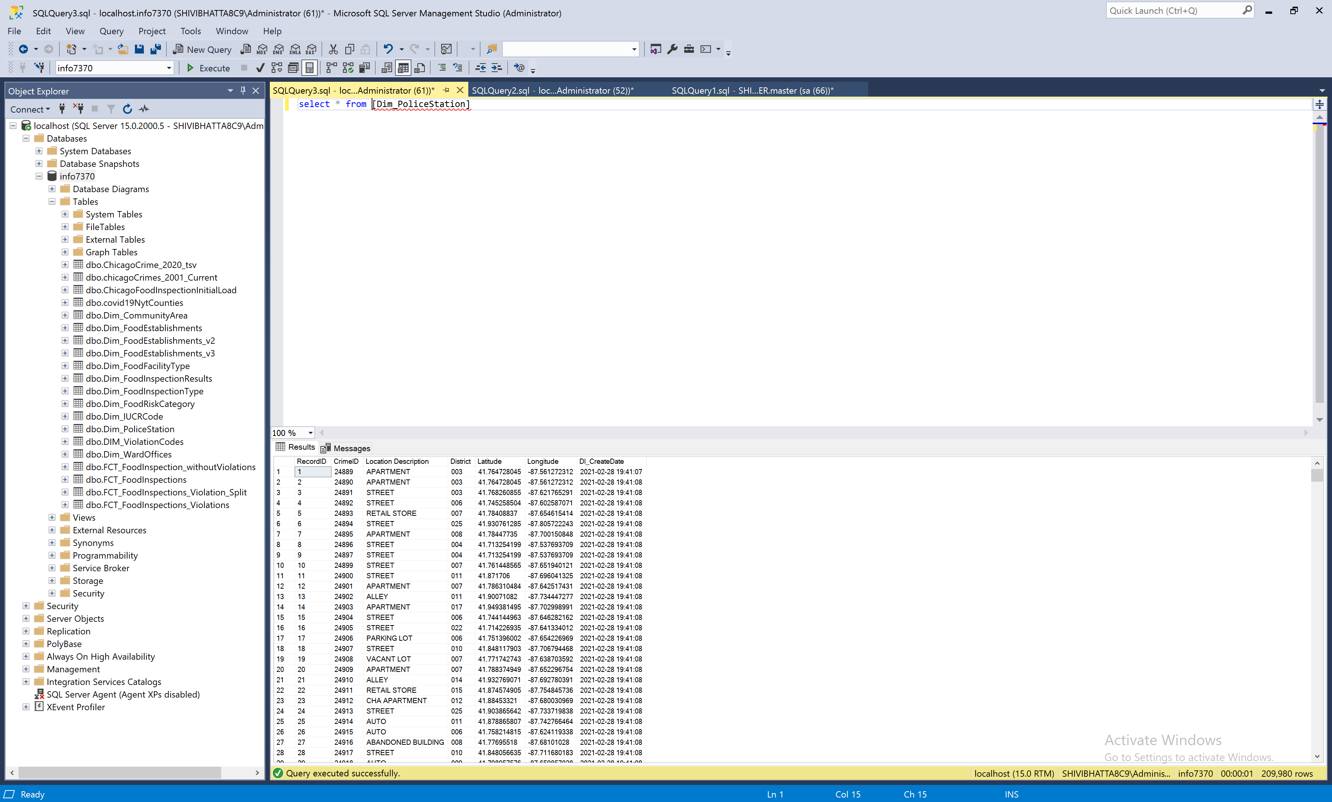

**Dimension : WardOffices**

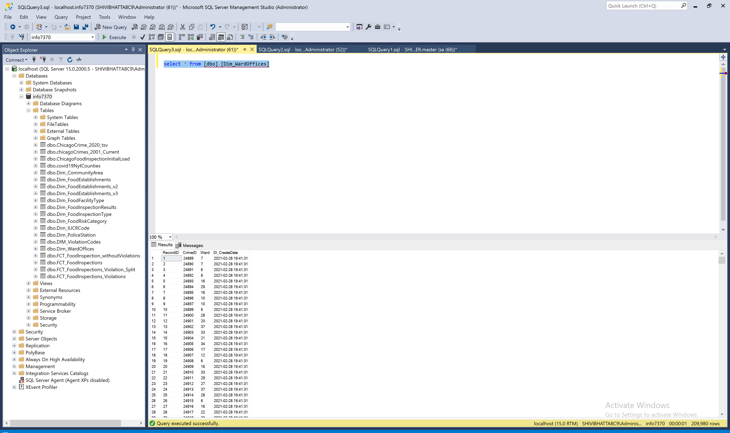

**Dimension : Community Area  
  
  
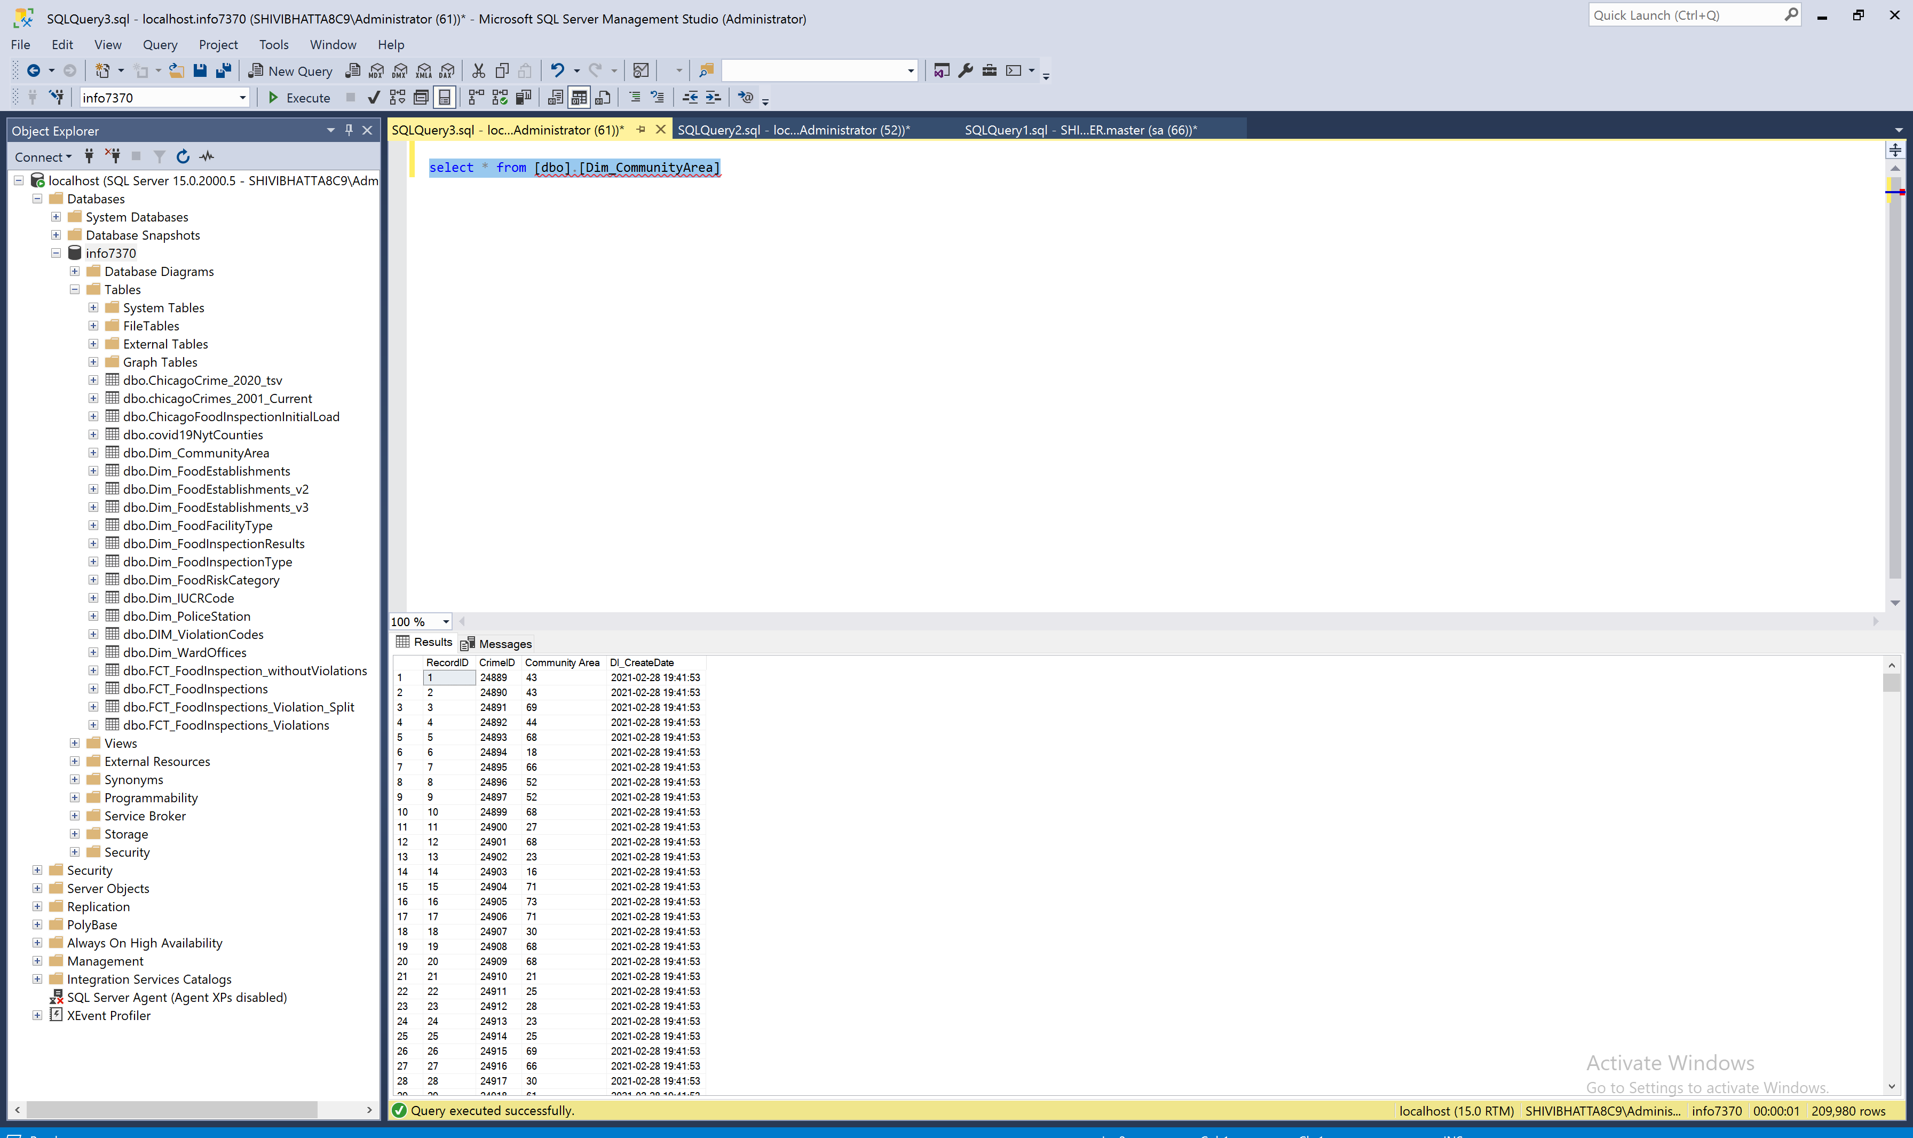**

**Google Data Studio Visualizations**